**Earth-Moon Communication from a Moving Lunar Rover**

**Deepak Bapna, Martin Martin and William Whittaker**

**The Robotics Institute, Carnegie Mellon University**

**Pittsburgh, PA 15213**

***email: deepak@ri.cmu.edu, mm+@cmu.edu***

**KEYWORDS**

Telemetry, Highbandwidth, Mobile, Lunar

**ABSTRACT**

Carnegie Mellon University has proposed an educational- and entertainment-based robotic lunar mission which will last two years and cover 1000km on the moon and revisit several historic sites. With the transmission of live panoramic video, participants will be provided the opportunity for interactively exploring the moon through teleoperation and telepresence. The requirement of panoramic video and telepresence demands high data rates on the order of 7.5 Mbps. This is challenging since the power available for communication is approximately 100W and occupied bandwidth is limited to less than 10 MHz. The tough environment on the moon introduces additional challenges of survivability and reliability.

A communication system based on a phased array antenna, Nyquist QPSK modulation and a rate 2/3 Turbo code is presented which can satisfy requirements of continuous high data rate communication at low power and bandwidth reliably over a two year mission duration. Three ground stations with 22m parabolic antennas are required around the world to maintain continuous communication. The transmission will then be relayed via satellite to the current control station location. This paper presents an overview of the mission, and communication requirements and design.

**INTRODUCTION**

The Lunar Rover Initiative (LRI) [10], undertaken by the Planetary Robotics Program at the Robotics Institute, Carnegie Mellon University, is chartered to place a robotic vehicle on the Moon before the year 2000. LRI has chosen a mission focused on providing entertainment and education, or “ *edutainment*”, rather than the science agenda of traditional space exploration. The main product of the mission is high-quality, panoramic, color video returned to the Earth and displayed in real-time, which is suitable for movies, television broadcasts, CD-ROMS, and when combined with the rover motion history can be used to generate highly realistic telepresence experiences or inputs for geological analysis. The goal of the mission is to increase awareness about robotics and planetary exploration among mass audiences and to demonstrate success of low cost space missions. The mission will attempt a 1000km traverse on the moon, visiting historic landing sites, and involving audience participation through teleoperation and the high-quality images and video returned. Two rovers of equal capabilities will move in a leap-frog fash-ion.

Traditional planetary telemetry between the Earth and a mobile platform on the moon involves either relaying data through a stationary lander or storing information and transmitting in bursts through an orbiter which then forwards the signal to the Earth. In the lander scenario, the need to relay limits the excursions of the mobile platform to the region within line-of-sight of the lander, a 3-4 km radius on the Moon, and places substantial demands on the lander for power, thermal, communication, and other sys-tems. In the orbiter scenario, the mission is confined to a narrow band on the moon, and is constrained by intermittent, short uplink windows. Both scenarios probably cost more, weigh more, and entail greater risk than a self-reliant rover which communicates directly with a station on the Earth.

The technical challenge in achieving rover self-reliance lies in achieving the high data rate required for entertainment, and valuable for science, while roving. It is notable that the significant data rates needed to support video for entertainment far outscale the low data rates motivated by traditional plane-tary science experiments. Current mobile communication systems use low gain, omnidirectional antennas in order to ensure uninterrupted coverage while traveling. The capacity of the communications link is limited and the data rate is severely restricted at reasonable power levels. With an omnidirectional link a high data-rate can be achieved only over a distance less than several kilometers. The data rate can be increased by boosting power or increasing the receiving antenna size, and these strategies can be effective for orbiting platforms and large ground vehicles such as tanks. However, the resulting escalations in power budget and component size to achieve high data rate transmission over long propagation paths are not tolerable for small roving vehicles. The highest data transmission rates can be achieved by precisely pointing the transmitter antenna (towards the receiver). Hence, a high gain narrow beam directional antenna is the only feasible option for direct communication between a rover and the Earth.

**REQUIREMENTS**

The primary product of the mission is high quality video images. It is therefore important to achieve as high a data rate as possible. The main objective of the communication system is to support this data rate reliably over the duration of mission operations. Based on this, the main requirements from rover communication hardware and earth stations are given below.

**Rover-End**

* The communication system should be able to transmit as high a data rate as possible with appropriate link margin.
* It should be able to receive commands from an Earth station at all the times during mission duration.
* It should be able to operate for at least 2 years in the lunar environment.
* Surface area of the antenna should either be limited to about 1 m2 or appropriate strategy for stowing/deployment should be provided.
* Power should be limited 100 W.
* Mass should be limited to 20 Kg.
* System should be ready for tests by 1998.
* Cost should be limited to $5 M for communication system of each rover.
* It should be protected from lunar dust and micro-meteorites.
* It should be able to survive the lunar night.
* It should be able to dissipate appropriate heat during operation.

* It should survive launch loads.
* New developments should be avoided whenever possible.
* Complete failure of a single rover should not degrade communications from the other rover.
* In the event of complete failure of the primary antenna on one rover, the damaged rover should be able to transmit through the primary antenna on the second rover.
* There should be no single point failure in the system.
* 99% of transmitted power must be contained within 10 MHz RF bandwidth
* The bit error rate should be less than 10-6.

**Earth-End**

* The control station should be able to receive data from and transmit data to the rovers (directly or through other stations or satellites) at all times during mission duration.
* The configuration of earth stations (and/or satellites) should be such that the time delay is minimum.
* Operation cost should be minimal.
* Earth Stations should be ready by mid 1998.
* There should be no single point failure.
* The error correction codes must be decoded in real time.

**FREQUENCY LICENCING**

Frequency licensing is one of the key issues for the communication system and the mission. It is critical due to the following reasons:

* RF frequencies are required to transmit from the rovers1 and to control the rovers.
* The maximum data rate is primarily limited by the bandwidth allocation.
* Frequency licensing is required from all the countries where earth stations will be installed.
* Frequency allocation usually takes time (2-3 years).

Various bands (S, X, Ku, Ka) for space research [12] were considered and analyzed. With the limited power available at the rover, Ka-band does not serve the purpose due to very high rain attenuation. S-band and X-band are preferable due to low attenuation. Although Ku-band has higher attenuation than S-band and X-band it can be used. The main difficulty is that the bandwidth allocation is not guaranteed in this band. Also, S-band is reserved for government/military use. After discussions with the OSC (Office of Space Communications, NASA HQ) and the FCC it seems likely to get 10 MHz in X-band (Space research band- 8450-8500 MHz). As discussed later in the document, this would support about 7.5 Mbps of raw video and data.

**CONFIGURATION**

The communications architecture consists of several antennas to allow for high-bandwidth communication between each rover and the Earth and between the two rovers. Specifically it consists of:

1. Optical communication does not need RF frequencies, but the technology is not mature enough as discussed later.

* A high gain antenna (X-band transmit) on each rover to communicate directly with an earth station.
* Omnidirectional antenna (VHF/UHF) on each rover for interrover communication. This could be used if the high gain antenna on one of the rovers fails. In this case the rover can communicate with the Earth through the other rover.
* Omnidirectional antenna (X-band) on each rover to receive commands from Earth. In an emergency it can also transmit to Earth directly at low data rate.
* Three earth stations (X-band) probably located in US, Russia and Australia to ensure round the clock coverage.

Most of the attention in this paper goes to the primary downlink from the rover to the Earth since its requirements are the most stringent. However, mention will also be made of the backup and inter-rover antennas.

**Antenna Options**

The primary antenna serves to relay all the video and telemetry data to Earth. The data requirements are estimated to be on the order of 7.5 Mbps. Four different communication technologies were considered for the main communications link to Earth: omnidirectional, parabolic dish, phased array, and optical.

**Omnidirectional Antenna:** Although omnidirectional antennas are widely used and have an extensiveflight history, it would require hundreds of watts of output power (kilowatts of input power) to transmit the required bandwidth. Use of an omnidirectional antenna for the primary communications link could not be seriously considered for this reason.

**Parabolic Dish:** Parabolic dishes are the most widely used antennas for high bandwidth communicationsfor space applications. The technology is well understood and has proven very reliable. They provide high gains, enabling high bandwidth communication over long distances without consuming much power. However, most of this work has been from stationary or slow moving platforms. For this application a par-abolic dish must be mechanically pointed with high precision, which is a major challenge from a moving rover.

**Phased Array:** Although a less mature technology than parabolic dishes, phased arrays have maturedgreatly over the last couple years [3] and are beginning to see some flight tests. Phased arrays have several advantages. They are usually more efficient than parabolic reflectors. Also, the beam may be electroni-cally, rather than mechanically, pointed by adjusting the phases of the individual transmitters. This allows for very fast and precise steering of the communications beam which is very important for high bandwidth communication since the data rate decreases with increase in angular offset.

**Optical Communication:** Optical communication is relatively new and there are many unsolved prob-lems. The main reason for its consideration is that the bandwidth licensing problems do not exist with opti-cal communication, and the beam is so narrow and receivers so sparse that there is no possibility of interfering with another transmission. It also has the advantage that the components are small and an opti-cal communication device would not occupy a large portion of the area on top of the rover. However, the pointing problem is severe. Additionally, building the ground station and its pointing device would also be

difficult and very expensive. Since there is so little experience in the field, most of the hardware would have to be developed and custom-built.

**PRIMARY ANTENNA**

Based on the trade-offs outlined above, it was decided that a phased array antenna operating in the X-band portion of the frequency spectrum was the best option. To achieve the necessary data rate, the phased array will consist of 683 elements and the Earth receiver station will have a 22 meter dish. The phased array will



**0.55 m diameter Phased Array**

**683 Transmitter elements**

**Gain = 28.9 dB**

**0.55 m**



**Figure 1 Phased Array Antenna**

have scan capability of +/-60 deg to account for Earth-Moon motion and vehicle motion. The input attitude to phased array will be provided using IMU and Star tracker. The phased array antenna layout is shown in Figure 1. A data flow diagram for the communication system is shown in Figure 2.

The link budget for the downlink ([4], [5], [6], [7]) is shown in Table 1.

***Table 1*** *Link Budget (Downlink)*

|  |  |  |
| --- | --- | --- |
| **Parameter** | **Value** | **Comments** |
|  |  |  |
|  |  |  |
| Frequency | 8.495 GHz | X-Band for Space Research |
|  |  |  |
| Data Rate | 7.5 Mbps | Possible in 10 MHz Bandwidth |
|  |  |  |
| Transmitter Diameter | 0.55 m |  |
|  |  |  |
| Number of Elements | 683 |  |
|  |  |  |
| Transmitter Gain | 28.9 |  |
|  |  |  |
| Transmitter Power | 12 W |  |
|  |  |  |
| Beam Width | 3.6 deg |  |
|  |  |  |

**Video Cameras**

|  |  |  |  |  |
| --- | --- | --- | --- | --- |
|  |  | **Digitizers** | **Compression** |  |
| 4 analog | |  |
| 4 digital |  |
| video | |  | video streams |  |
| streams | |  | 590 Mbps |  |
|  |  |  | compressed |  |
|  |  |  | video |  |
|  |  |  | 7 Mbps |  |

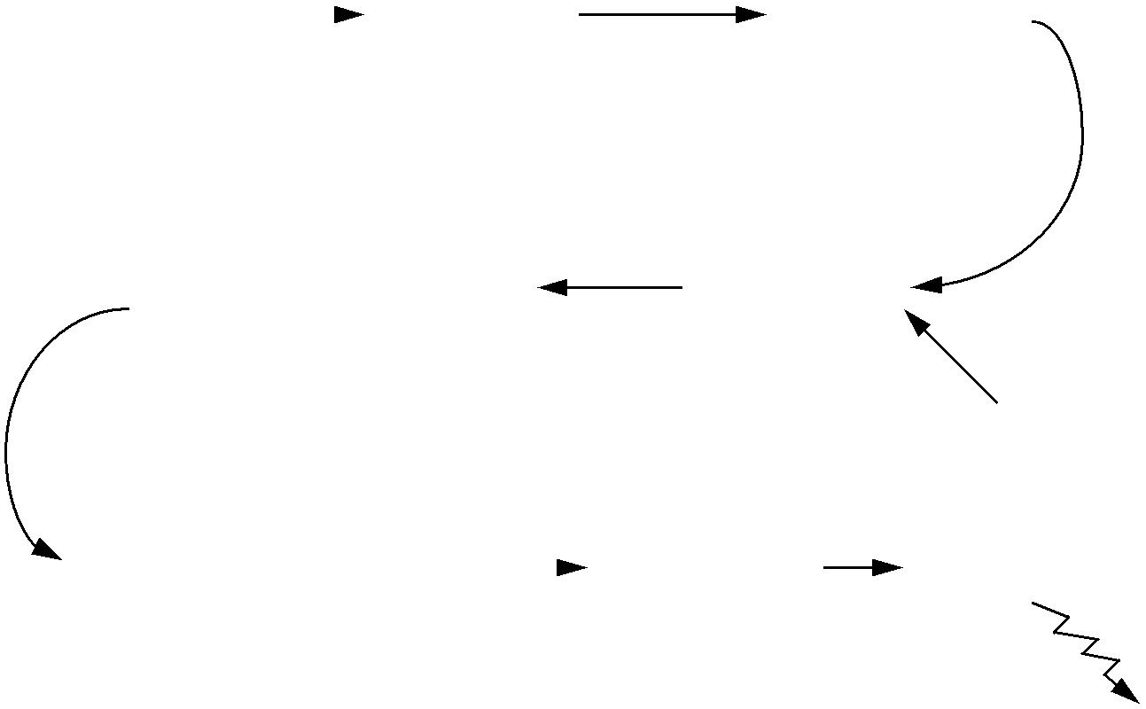

|  |  |  |  |  |  |  |  |  |  |  |
| --- | --- | --- | --- | --- | --- | --- | --- | --- | --- | --- |
|  | **Rate 2/3 Turbo** | | |  |  | 7.5 Mbps **Multiplexer** | | |  |  |
|  | **Error Correction Code** | | | | |  |  |  |  |  |
|  | 11.25 Mbps | | |  |  |  |  | **Telemetry** |  |  |
|  | **60% Excess BW** | | |  |  |  |  | **Phased** |  |  |
|  | **Raised Cosine** |  | |  |  | **Bandlimiting** | |  |  |
|  | **QPSK Modulation** | Analog signal, | | |  | **Filter** | | **Array** |  |  |
|  |  | 8.475 GHz carrier, | | | | | |  |  |  |
|  |  | 9 MHz Bandwidth | | | | | |  |  |  |
|  |  |  |  |  |  | | |  |  |  |
|  |  |  |  | **Figure 2 Data Flow** | | | |  |  |  |
|  | ***Table 1*** *Link Budget (Downlink)* | | | | |  |  |  |  |  |
|  |  |  | |  |  |  |  |  |  |  |
|  | **Parameter** | |  | **Value** | |  |  | **Comments** |  |  |
|  |  |  |  |  |  |  |  |  |  |  |
|  |  |  |  |  |  |  |  |  |  |  |
|  | Receiver Diameter | |  | 22 m | |  |  |  |  |  |
|  |  |  |  |  |  |  |  |  |  |  |
|  | Receiver Gain | |  | 63.6 dB | |  |  |  |  |  |
|  |  |  |  |  |  |  |  |  |  |  |
|  | Noise Temperature | |  | 400 K | |  |  |  |  |  |
|  |  |  |  |  |  |  |  |  |  |  |
|  | EIRP | |  | 35.7 dBW | |  |  |  |  |  |
|  |  |  |  |  |  | |  |  |  |  |
|  | Flux Density | |  | -148.7 dBW/m2 | | |  |  |  |  |
|  | Eb/N0 | |  | 6.7 dB | |  |  |  |  |  |
|  |  |  |  |  |  |  |  | |  |  |
|  | Required Eb/N0 | |  | 2.0 dB | |  | QPSK + Turbo Codes | |  |  |
|  |  |  |  |  |  |  |  |  |  |  |
|  | Link Margin | |  | 4.7 dB | |  |  |  |  |  |
|  |  |  |  |  |  |  |  |  |  |  |

**INTER-ROVER COMMUNICATION**

There will be an omnidirectional antenna on each rover for inter-rover communication. The antenna will operate in VHF since there is an abundance of available components in that frequency band. A link analysis showed that 1W is enough to enable all data (7.5 Mbps) to be sent from one rover to the other up to a distance of 2km.

Phased Array

* 28.9 dB Gain
* 683 elements
* Transmit
* 12 W
* Circular Polarization

Receiver Dishes

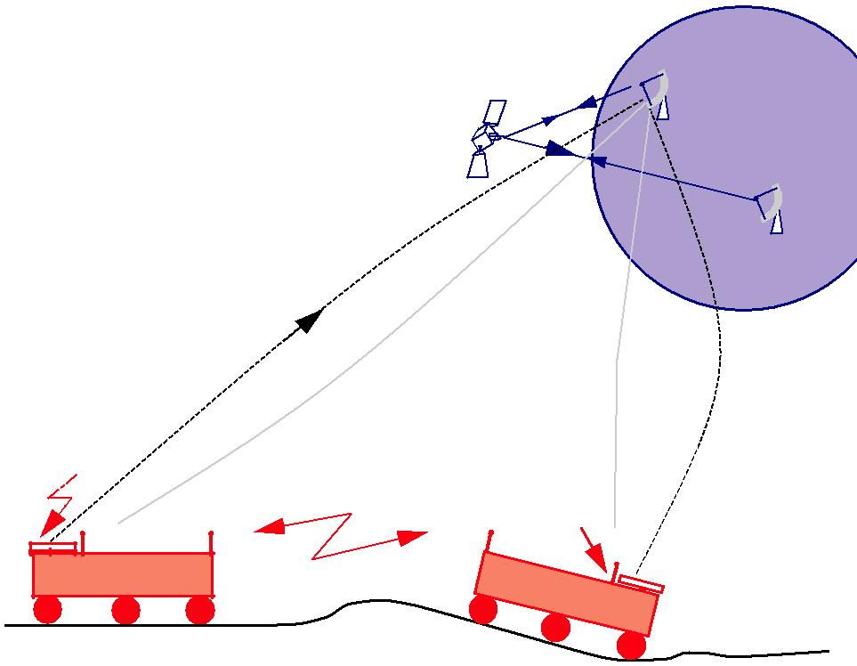

|  |  |  |
| --- | --- | --- |
| - 22 m Aperture | **EARTH** |  |
| -400 K Noise Temp. |  |
| - RHCP/LHCP |  |
|  |  |
| - Receive/Transmit |  |  |

X-Band

Downlink- 8490-8500MHz 7.5 Mbps

VHF omni (inter-rover)

7.5 Mbps

X-band Omni

MOON

**Figure 3 Overall Communication Configuration**

**OMNIDIRECTIONAL RECEIVERS**

An omnidirectional antenna is used to receive commands from the Earth. This can also transmit in case the primary antenna loses its lock on Earth (or the primary antennas on both rovers fail). Since there are no pointing requirements for omnidirectional antennas, low bandwidth communications over the backup omnidirectional link is possible even when the primary antenna has lost its lock. This backup thus enables the system to send some sort of heartbeat signal and receive commands at all times. If the data feed from the rover ceases on Earth, it is possible to send a “lost signal” message and a “realign antenna/search for Earth” command. The omnidirectional antennas are currently designed to produce a 1W signal, requiring a power input of approximately 10W.

**MODULATION AND ERROR CORRECTION CODING**

To fit approximately 7.5 Mbps in 10 MHz, bandwidth efficient modulation techniques are required. Also, given the power constraints of the rover, the modulation method must also be power efficient. There are two techniques that meet the requirements of the Lunar Rover Initiative, Nyquist QPSK [11] and contin-uous phase modulation (CPM) ([1], [9]).

With Nyquist QPSK, the power amplifier must be linear, which is less power efficient than one which operates in saturation only. The theoretically optimum bandwidth efficiency is 0.5 Hz/bps, how-ever this isn’t achievable in practice. As well, the more excess bandwidth one allows, the more localized the pulse is which reduces the problem of intersymbol interference. The amount of excess bandwidth needed depends on the exact design, but numbers from 35% to 100% are reasonable. In 9 MHz, not including error correction coding (see below), 100% would result in 1 Hz/bps (9 Mbps) and 35% would result in 0.675 Hz/bps (13.3 Mbps).

Alternatively, using CPM with a 3 symbol duration raised cosine pulse will achieve a bandwidth of

0.75 Hz/bps (12 Mbps uncoded in 9 MHz), with the same power requirements as for Nyquist QPSK. Another option is to decrease the magnitude of the phase change, which will decrease the occupied band-width but require more power to help distinguish the more similar signals. For an increase of 1.8 dB power, the bandwidth drops to 0.6 Hz/bps (15 Mbps uncoded in 9 MHz).

As the Nyquist QPSK is easier to implement, it has been selected for the mission, with an excess bandwidth of 60%. At 0.8 Hz/bps, we can realize 11.25 Mbps of error correction coded signal in 9 MHz, leaving a 1 MHz margin.

The data stream must also be error correction encoded to reduce the error rate to acceptable levels. The CCSDS standard for error correction in space applications, for a resultant bit error rate of 10-6, requires a signal to noise ratio of approximately 3 dB, and the usable data rate would be 44% of the mod-ulated rate. For the modulated rate of 11.25 MHz above, that would be a data rate of 5Mbps. Space qual-ified hardware already exists that implements the standard.

Recently, however, a new way of interleaving recursive convolutional codes has been found that per-forms near theoretical limit ([2], [8]). These codes, called Turbo Codes, were discovered in 1993 and have been a hot research topic since. For our purposes, the best code would be a rate 2/3 code that has a required signal to noise ratio of 2 dB (or 3.8 dB, if used in conjunction with 0.6 Hz/bps CPM). Although still young, they appear easy to encode. For this reason they will be used on the Lunar Rover. They will achieve a usable data rate of 7.5 Mbps with the conservative modulation scheme, and 10 Mbps if the 0.6 Hz/bps CPM becomes available.

**FAILURE MODES**

Complete failure of communications would be disastrous to the mission. The communications system is robust to failure in several ways. First, the phased array has inherent redundancy: failure of a few transmitters will not seriously degrade antenna performance. Second, if the phased array does completely fail, communication to Earth is still possible via the inter-rover communications link and the other rover’s phased array. Third, the backup omnidirectional antennas provide a link to Earth which is not subject to pointing problems, albeit at a greatly reduced data rate. Table 2 shows the effects of failure of various components.

|  |  |  |  |  |  |
| --- | --- | --- | --- | --- | --- |
| *TABLE 2* | *Failure Modes* |  |  |  |  |
|  |  |  |  |  |  |
| **Component** | **Failure Mode** | **Effect** | **Prevention and/or** | **Criticalitya** |  |
| **Response** |  |
|  |  |  |  |  |
|  |  |  |  |  |  |
|  |  |  |  |  |  |
|  | Single/Multiple | Insignificant | 683 elements | 3 |  |
| Phased Array | Transmitter Failures |  |
|  |  |  |  |
|  |  |  |  |  |
|  | Complete Failure | Little or None | Transmit via other rover | 2 |  |
|  |  |  |  |  |  |
| Inter-rover |  | None, but loss of | Inter-rover link is a |  |  |
| Single Failure | product if phased | secondary communication | 3 |  |
| Link |  |
|  | array fails too | link |  |  |
|  |  |  |  |
|  |  |  |  |  |  |
| Omni- | Transponder Failure | No receive Signals | Redundant transponder | 1 |  |
| directional |  |
|  |  |  |  |  |
|  |  |  |  |  |  |

a. 3 denotes very low criticality whereas 1 may lead to mission failure.

**COMPONENTS/SUBCONTRACTS**

Several sources for components has been identified as tabulated below:

***Table 3*** *Component Sources*

|  |  |  |
| --- | --- | --- |
| **Component** |  | **Sources** |
|  |  |  |
|  |  |  |
| Phased Array Antenna |  | Matra Marconi; SPAR; Ball Aerospace; Westinghouse; Harris |
|  |  | Corp.; |
|  |  | Malibau Research; CV Engineering |
|  |  |  |
| Inter-rover Communication |  | Motorola; Loral Conic; E Systems; |
|  |  | Texas Instruments |
|  |  |  |
| Back-up Omnidirectional |  | Motorola; Loral Conic; E Systems; |
|  |  | Texas Instruments |
|  |  |  |
| Receiver Dishes |  | Scientific Atlanta; Datron |
|  |  |  |
|  | **MASS/POWER BUDGET** | |

The following table (Table 4) shows the mass and power budget for the communication system. The mass and power are within the required limits.

***Table 4*** *Mass and Power Budgets*

|  |  |  |  |  |
| --- | --- | --- | --- | --- |
|  |  | **Total Mass** | **Average** |  |
| **Component** | **#** | **Power** |  |
| **[kg]** |  |  |
|  |  | **[Watts]** |  |
|  |  |  |  |
|  |  |  |  |  |
|  |  |  |  |  |
| Phased Array | 1 | 12 | 90 |  |
|  |  |  |  |  |
| Transponder | 1 | 0.75 | 5 |  |
|  |  |  |  |  |
| Inter-Rover link | 1 | 0.75 | 1 |  |
|  |  |  |  |  |
| Omni-directional | 1 | 1 | 10a |  |
| Antennas |  |
|  |  |  |  |
|  |  |  |  |  |
|  |  |  |  |  |
| Total |  | 14.50 | 96 |  |
|  |  |  |  |  |
| a. not used unless phased array fails | |  |  |  |

**SUMMARY**

The paper presented an overview of the LRI mission, its unique communication requirements and design. The power and bandwidth available for planetary missions are usually limited and providing continuous high data rate communication is a challenging. A communication system design based on a phased array antenna, Nyquist QPSK modulation and a rate 2/3 Turbo code is presented which can provide continuous high data rate communication at low power and bandwidth.

**ACKNOWLEDGEMENTS**

The LRI design activity at Carnegie Mellon University is supported by a grant from the NASA TRIWG (Tele Robotics Inter-Center Working Group), a project led by Dave Lavery. We are also thankful to various individuals at JPL and NASA Lewis for useful information and comments.

**REFERENCES**

1. Anderson, J. and Sundberg, C. “Advances in Constant Envelope Coded Modulation”, *IEEE Communications Magazine*, Dec. 1991, pp. 36-45.
2. Divsalar, D. and Pollara, F., “Multiple Turbo Codes for Deep-Space Communications”, TDA Progress Report 42-121, May 15, 1995. Available on the NASA‘s Advanced Missions WWW Home Page.
3. Edelson B.I. and Pelton J.E. (Eds.), “Satellite Communications Systems and Technology”, International Technology Research Institute, JTECH/WTEC Program, Loyala College, Maryland, July 1993.
4. Jessop, G.R.“VHF/UHF Manual”, 4th Edition, Radio Society of Great Britain, 1983.
5. Kitsuregawa, T., “Advanced technology in satellite communication antennas: electrical and mechanical design”, Artech House, Inc., Norwood, MA., 1990.
6. Larson, W.J. and Wertz, J.R., “Space Mission Analysis and Design”, 2nd Edition, Kluwer Academic Publishers, 1992.
7. Morgan, W.L. and Gordon, G.D., “Communications Satellite Handbook”, John Wiley & Sons, NewYork, NY, 1989
8. Robertson, P., “Illuminating the Structure of Code and Decoder of Parallel Concatenated Recursive Systematic (Turbo) Codes”, *1994 IEEE Globecom*, Vol. 3
9. Sasase, I. and Mori, S., “Multi-h Phase-Coded Modulation”, *IEEE Communications Magazine*, Dec. 1991.
10. Whittaker W. et al., “Rover Design for an Edutainment-Based Lunar Mission”, The Robotics Institute, Carnegie Mellon University, Pittsburgh, Sept. 1995.
11. Ziemer, R.E. and Peterson, R.L., “Introduction to Digital Communications”, Macmillian 1992.
12. “Code of federal regulations”, 47, Parts 0 to 19, Published by the office of the Federal Register National Archives and Records administration, Washington DC, 1994.